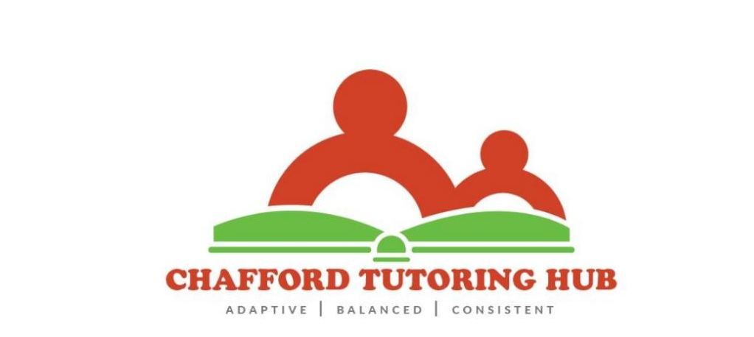
SAFEGUARDING CHILDREN/ CHILD PROTECTION
We work with children, parents and external bodies to ensure the welfare and safety of all the children who attend our centre. Every child has the right to be treated with respect, to thrive and to be safe from any form of abuse.
At Chafford Tutoring Hub we aim to:
-Keep the child at the centre of all that we do.
-Ensure that all members of staff are trained to understand the safeguarding policy and procedure, are equipped to identify the possible signs of abuse.
-Provide all staff with regular updates with child protection training and to ensure that staff are confident to act in the best interest of the child
-Ensure that all staff receive a Prevent Duty training and are aware of how to keep the children safe from the dangers of radicalisation and extremism.
-Make referrals in a timely manner, sharing relevant information as necessary in line with the procedures set out by the Local Safeguarding Children Board.
-Ensure that information is only shared with people who need to know in order to protect the child
-Ensure that all absences are written down and any concerns recorded are acted upon
-Review and update our policy regularly making sure that it complies with the requirements of the Local Safeguarding Children Board.

In all instances staff should record any observations or disclosures. This record should include:
-Name and address of child
-Date and time of the observation or disclosure
-Precise description of concern, for example exact words spoken by child, position and type of injuries or marks seen, who was present etc.
-Name of person to whom concerns were reported with date and time
-Any discussions held with parent(s)

The procedure above will be followed when a child tells us that they or another child is being abused.

It is important to mention the dangers of On-line Abuse and Internet Safety. We will where necessary discuss how to be safe on-line with the children.

Any concerns that we have of a child attending our centre will be dealt with it according to the procedures set out by the LSCB without delay.

If an allegation is made against a member of staff, student or volunteer who works at our centre, we will follow the procedure below.
The allegation should be reported to the manager, Beverlyn Cofie.
The Local Authority Designated Officer (LADO), Ofsted and the LSCB will be informed immediately for advice and guidance and to determine how this will be handled.

All members of staff, students and volunteers will be expected to be DBS checked before joining our team.

Useful Contact telephone numbers
Thurrock Multi Agency Safeguarding Hub (MASH) 01375 652802
Local Authority Designated Officer (LADO) Sharon Owen 01375 652732
Ofsted 0300 123 1231
Local Safeguarding Children Board (LSCB) 01375 652 802

